II- Major achivements during the Industrial Revolution :
- Identify the following new inventions in the Industrial Revolution and name the respective inventors
New inventions | Inventions / Inventors
a- | Invention : spinning jenny  Inventor : James hargreaves  Date :1764
b-  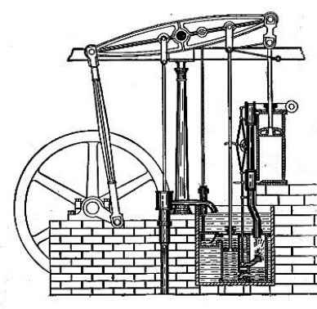 | Invention : steam engine  Inventor :James Watt  Date :1769
c-  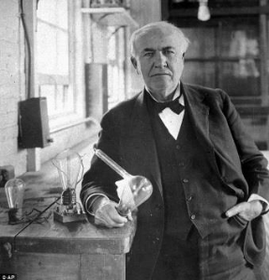 | Invention : new type of electrical ampoul  Inventor : Thomas edison  Date :1878
d-  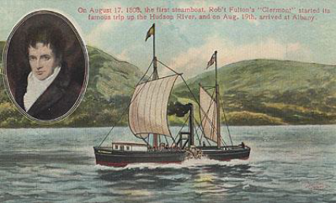 | Invention : ship  Inventor : Robert fulton  Date : 1909streambot
e-  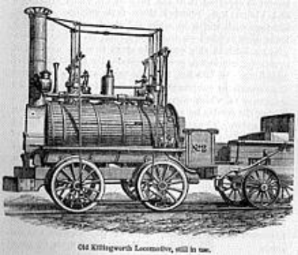 | Invention : steam train  Inventor : George Stephenson  Date : 1814
- Which invention do you consider to be the most important one made during the Industrial Revolution ? Explain your answer.

I consider streambot to be the most important invention during the Industrial Revolution.

Reasons : The ship is a very ingenious idea because this allows travel or to transport goods exemple coton, food,clothes etc… The ship allow to explore gigantic sea and more and explore the seabed.

- The following is about the life of a peasant called David, living in Britain before the Indutrial Revolution. Read the following first.
My Diary (28-9-1703)
I am a peasant living in a small village. I am busy every day. After farming, I usually make goods with simple tools in my home. People call it the domestic system of production. Our sources of power are only confined to humans, animals, wind and water.
I seldom leave my village because the roads are very poor. If I have to visit my mother in another village far away, I can only travel by boat or carriage. Sometimes, I communicate with them by post.

One day, David was brought into a time machine by a time traveller and travelled to the year 1899. When he opened his eyes after the time machine had landed, he was very horrified at the differences between his former life and the present life. He wanted to keep a memory of what he saw before returning back to the pre-industrial revolution period.
Please help him to complete his diary by describing the changements he saw in labour and way of life.

